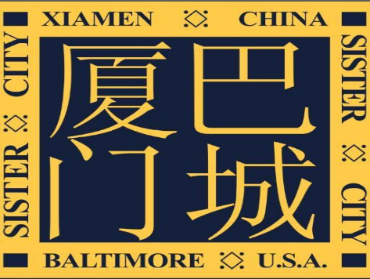
2019 BXSCC YOUTH
AMBASSADORS PROGRAM
APPLICATION

ESSAY
Name: Date:
- Please tell us about your experiences studying Chinese language and culture. If you have no experience, why do you have an interest in China now? (200 word max.)

- This trip will take students to several destinations in China, and will certainly include a visit to Baltimore’s sister city, Xiamen. Please look up one cultural/historic place in Xiamen, and discuss What about this place resonates with you and why you’d like to visit it (some examples to consider, include a university, a restaurant, a food/recipe/dish that is important to Xiamen, a museum, etc.) (200 words max.)

- During our trip, how will you connect to Chinese culture? (i.e. speaking as much Chinese as is possible, i.e. trying new foods, cultural exchange with Chinese peers)

- After you return from this trip what steps will you take to continue your study of Chinese language and culture? How will this trip help you in your current study of the language and/or culture? if you currently are not studying Chinese, how are you planning on learning Chinese language and/or culture upon returning? (200 words max.)

Student Bio
Please write a paragraph of self-introduction including your name (& Chinese name if applicable), grade level, hobbies, personal interests, travel experiences, Chinese learning background (if applicable), and other things that you would like to include. Please also include a picture of you at the end of the bio.

